SID : **1820376**

**Research Questions**

1. *One command I might use at a command prompt in Linux is “telnet”. What is it used for? Telnet is known to be insecure. Why? A better solution is “ssh” what does ssh stand for and why is it better?*

*The “telnet” command is used for communicating with other hosts using the TELNET protocol. It’s a client-server protocol that let’s the user connect to the remote host from the telnet client application.*

Telnet is known to be insecure because the protocol provides no build-in security measures. The session between the client and the server is not encrypted, therefore anyone with access to the TCP/IP packet flow between the communicating hosts can reconstruct the information between the end devices and read the data, including the usernames and passwords that are used to log in to the server. You should avoid using Telnet on public Internet due to the risk of eavesdropping.

SSH stands for Secure Shell, SSH is a software package that enables secure system administration and file transfers over insecure networks. The SSH protocol is an encrypted connection between the client and the server.

2. *Under MS-DOS there is a command “net user”. What is the purpose of this command? Give a single net user command line I can use to activate the hidden Windows user “administrator” explaining what each section of the command does.*

Net user is a command that adds or modifies user accounts, or displays user account information.

To activate the user “administrator” you have to right-click on the Command Prompt and select Run as Administrator, in the command prompt write this line : “net user administrator /active: yes”, which will activate the administrator mode. “Net User” let’s us modify anything in the Administrator account, changing the “Account Active” from “No” to “Yes”.

3*. In the context of the Android operating system, what is “rooting”? Why might I want to do it? What might this mean for me if the rooting goes wrong or I want to claim on the phone’s manufacturer warranty?*

For security reasons, phone manufacturers and mobile network operators enforce software limitations. These limitations can be eliminated by rooting your Android, even if is not advised to do so. Rooting is a process that gives you the ability to alter or replace the operating system code.

The benefits of rooting your phone would be: full customizations, download of any app from any app store, extended battery life, added performance and updates for outdated devices that are no longer updated by the manufacturer.

You can turn your phone into a brick by messing up the rooting process, and even if the process goes well, gaining root access also entails changing the security restrictions put in place by the Android operating system. Which means viruses, spyware and worms can infect the rooted software if it’s not protected by an effective antivirus for Android. As for the warranty, it turns void, it’s legal to root your phone, however, if you do it, your device gets straight out of warranty.

4*. A virtual machine can be designed to run on a thick or a thin client computer. What is the difference between a thick and a thin client computer? Where are the operating system files most likely to be stored in each type of computer?*

Firstly, a thin client offers the bare bones, simplified approach to computing, in which the client system has no hard drive, moving parts, or locally installed applications. These clients are designed to connect remotely into a separate server or data center that does all the work in a virtual environment. In this case security plays a huge role, as all the data is stored on the remote server, if the computer were to crash or get stolen, there’s no threat of losing valuable or private information.

Thick client PCs are fully assembled computers with all the hardware needed to function. Locally installed operating system and applications therefore all the computing is done there on the workstation.

The operating system files of a thin client are stored on a server or cloud, and on a thick client are stored locally on the system.

5. *A pre-installed application you may encounter on certain platforms is “safari”. What is safari? Give two operating systems which come with safari as a default application. What would be the equivalent built in default application in Windows 10?*

Safari is a web browser developed by Apple, based on the WebKit engine. This is the default browser on Apple devices, the main operating systems are macOS, iOS and IPadOS.

Windows 10, Windows 10 Mobile and Xbox One have Microsoft Edge as a default web browser, replacing Internet Explorer 11 and Internet Explorer Mobile.

**Exercises**

1. Write an MS-DOS batch or Linux shellscript program which prompts the user to enter a numeric expression (such as 2 * 14 + 6) and outputs the result to the screen.

I chose MS-DOS batch files.

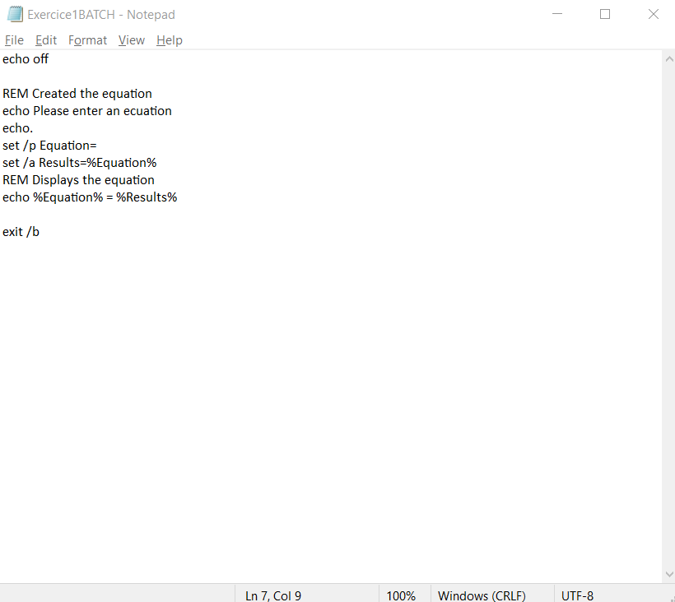

Set /p is used to prompt the user for input, here we’re prompting for an equation.

Set /a is used for arithmetic expressions, any calculation that return a fractional number will be rounded to the nearest whole number. So here, anything that the user will input will be taken as an arithmetic equation. Using the last echo to show us the result of the equation.

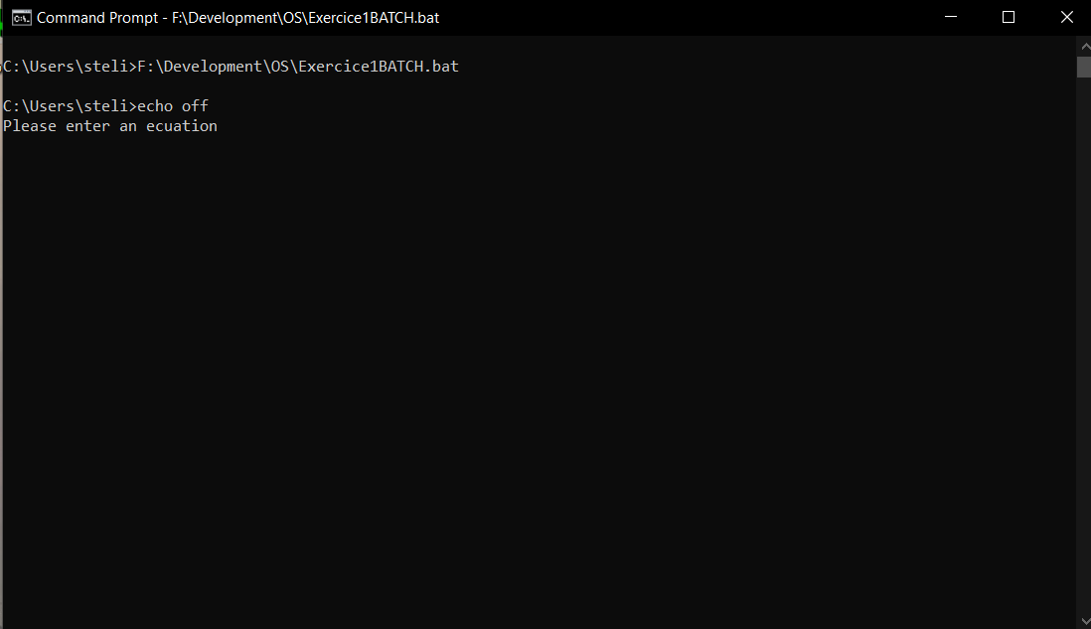

The user is prompted to insert an equation.

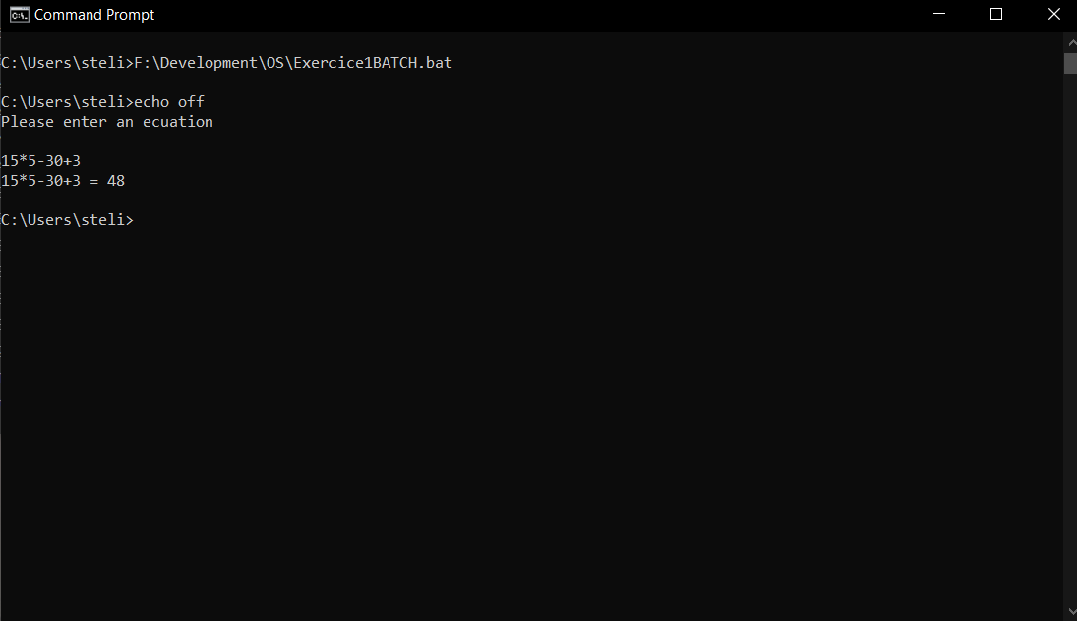

We can introduce more than two operands and more than one operator.

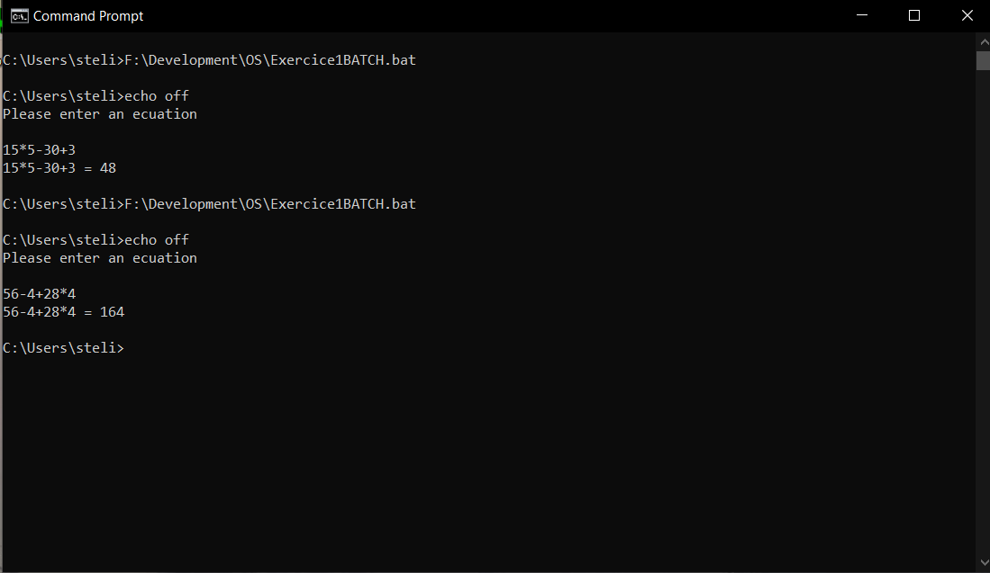

The .bat file has to be called every time for another equation.

1. Write an MS-DOS batch or Linux shellscript program which take one parameter on the command line which is the name of a directory. If the user does not enter any parameters on the command line it should prompt the user for it. If the directory does not exist, then it creates it or if the directory exists it tells the user the directory already exists.

I chose Linux shellscript.

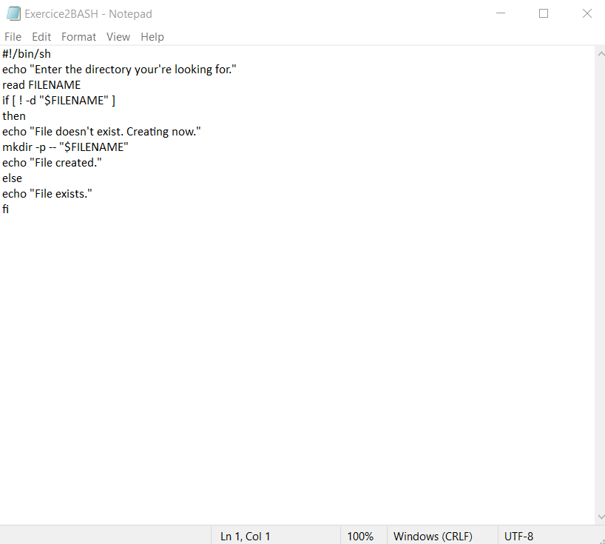

The user is prompted to enter a directory name.

The computer reads the name, then checks if the name is already there. If it does not exist, it prompts the user and creates it. If the directory exist already the user is prompted that it already exists.

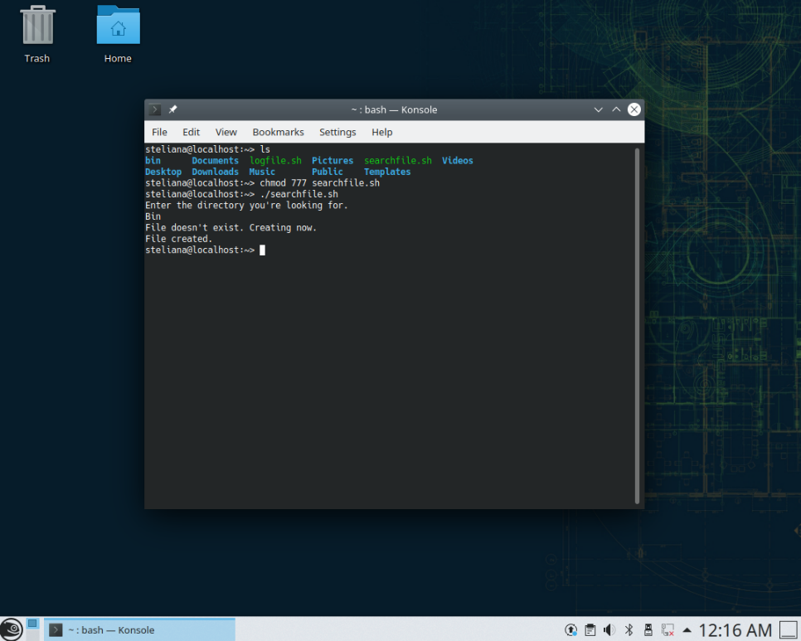

In this case we searched for a directory that did not exist. We got prompted that the directory got created.

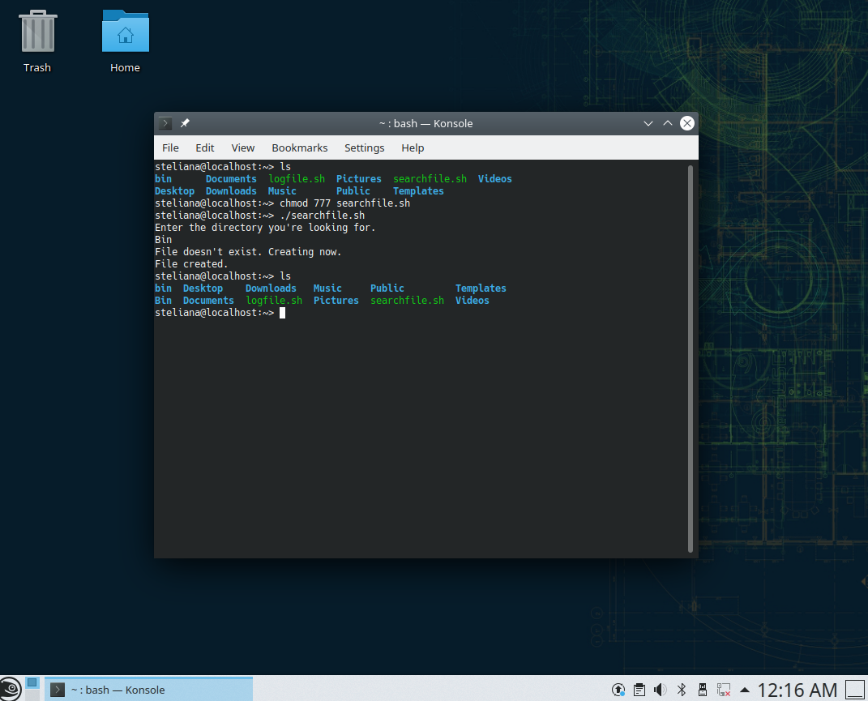

We checked and the directory was successfully created.

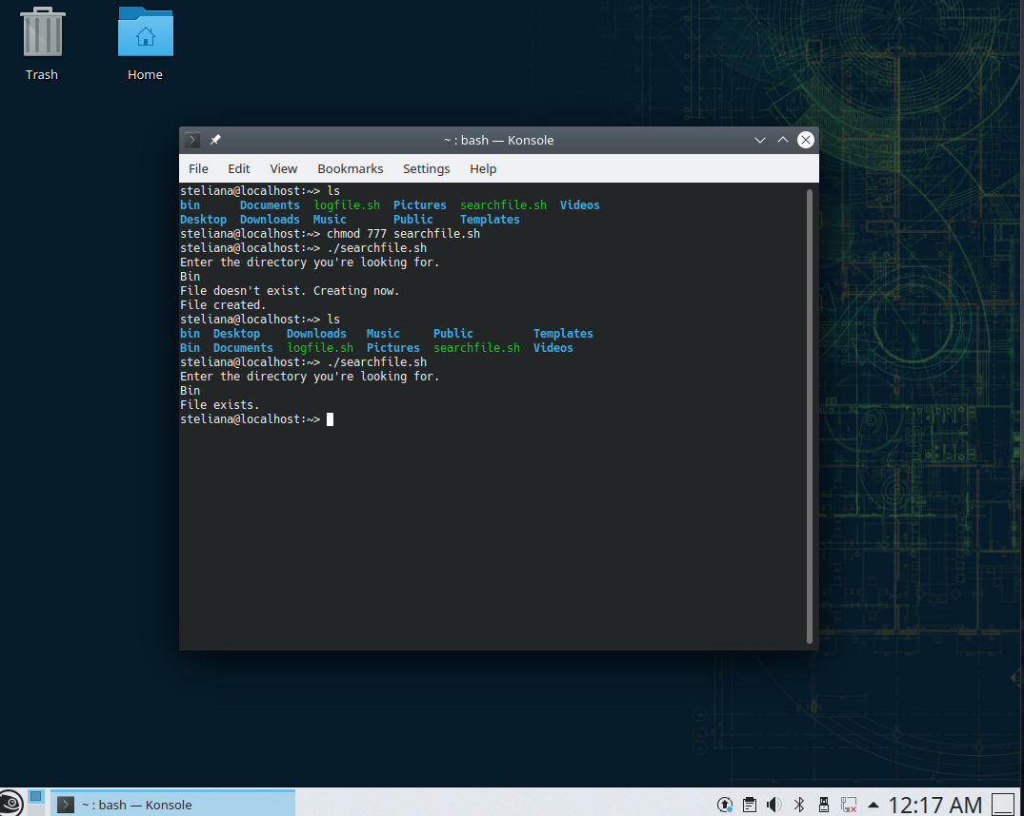

And checked if now it will read the directory and prompt us that it already exists.

1. Write an MS-DOS batch or Linux shellscript program helps maintain a log file. It should present the user with a menu with two options, option one prompts the user for a comment (it does not matter what) then adds a line to the end of a log file called “log.txt” (in the current directory) which contains the comment. It should preserve the previous contents of the file (if it exists). Option two deletes the log file.

I chose Linux shellscript.

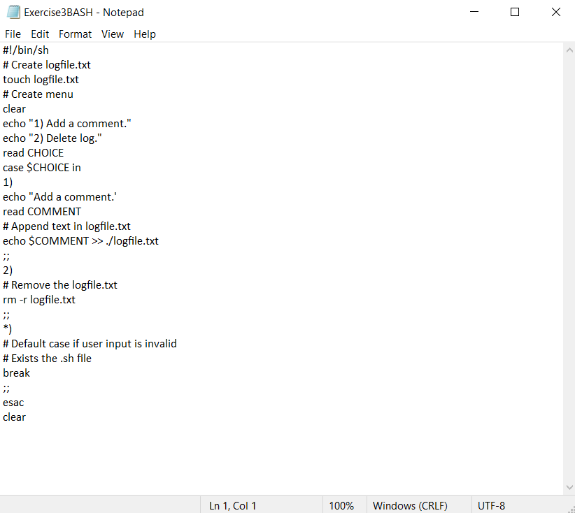

We first create the log file where we will store the comments. Then I created a menu so the user can choose to either add a new comment or delete the log file. For a comment the computer reads everything the user inserts and move it as a new element in the log file.

We have a default case that will terminate the program.

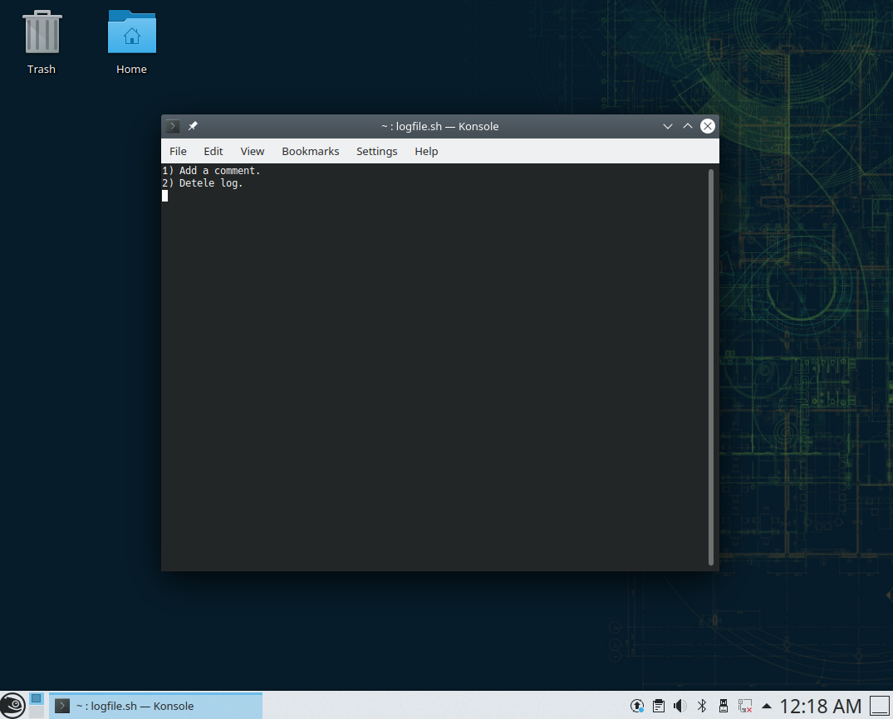

I went ahead and changed the mode and opened up the .sh file. Here we see the menu.

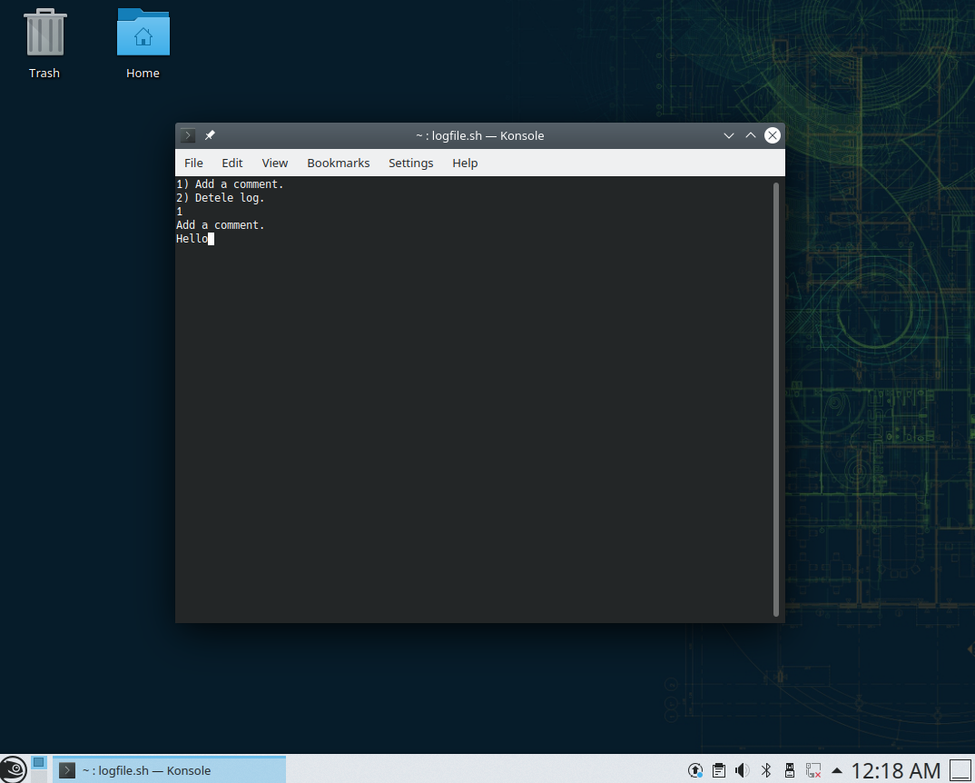

I entered a “Hello” and separately a “World” which I did not take a screenshot of.

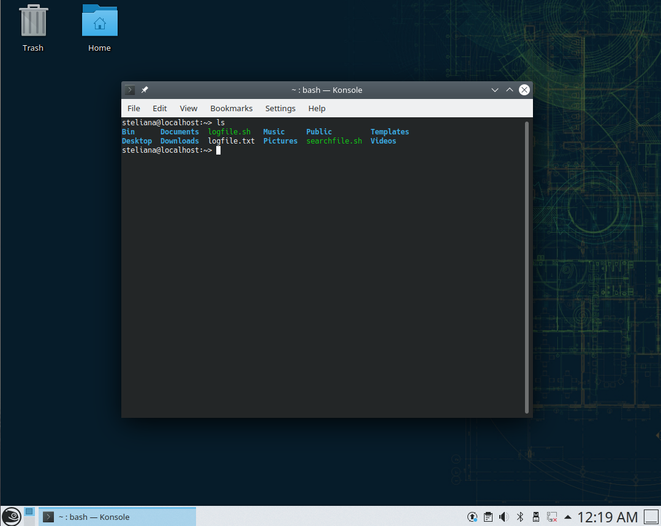

After adding some comments, I checked if the logfile.txt was created .

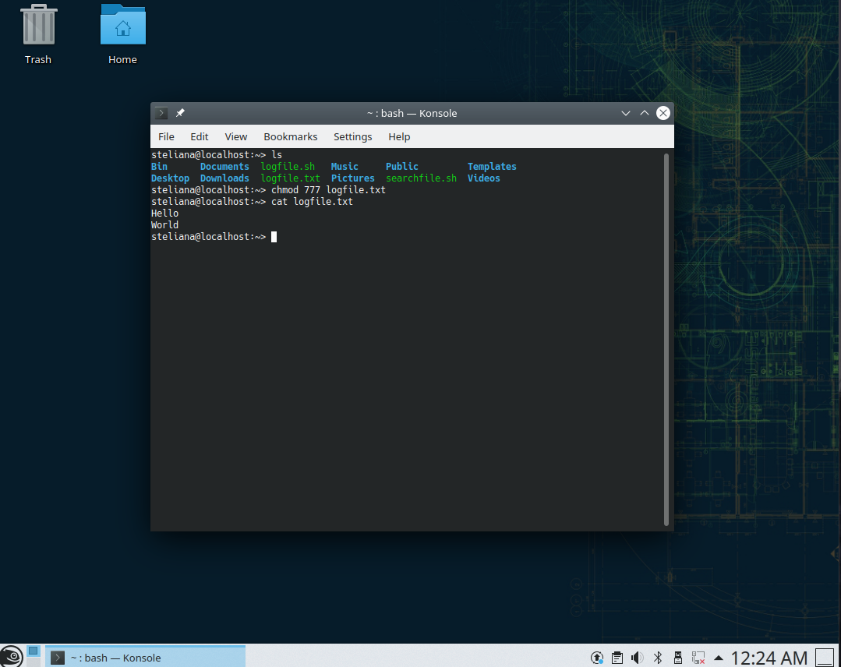

I changed the mode to the .txt file to see if the content was right. Concatenated the file so ill be able to see the full content of the .txt file.

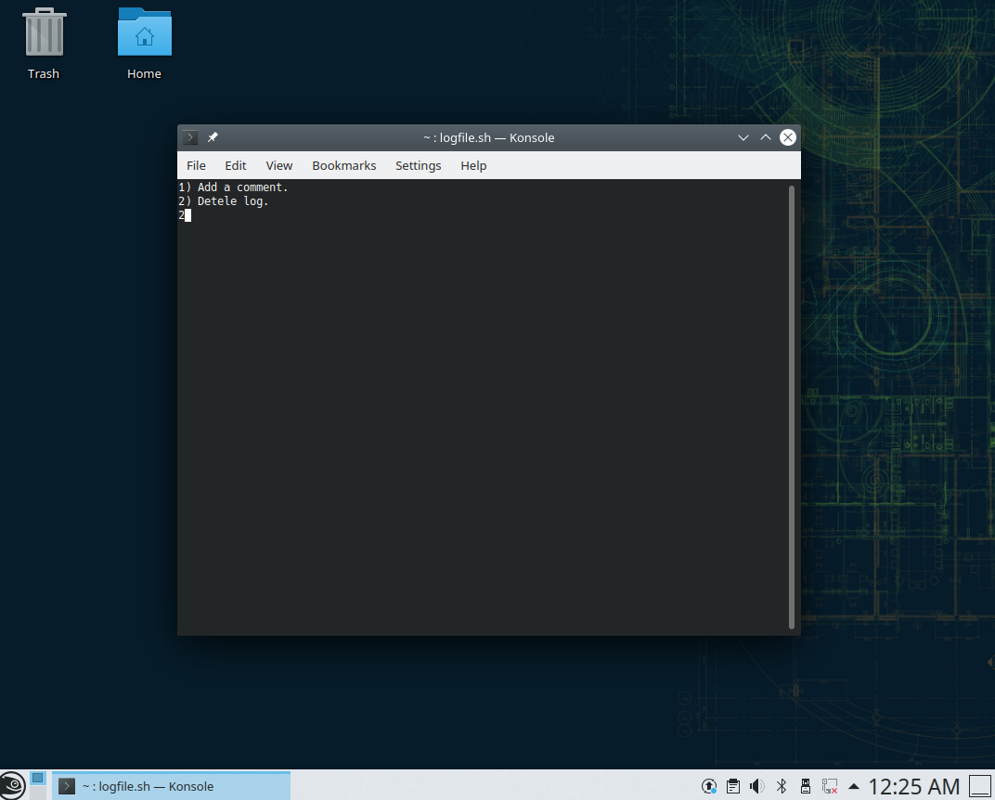

Now to delete the log file I’ll just go back to the menu and select option 2. Which will not prompt the user with anything and will bring you back to the konsole.

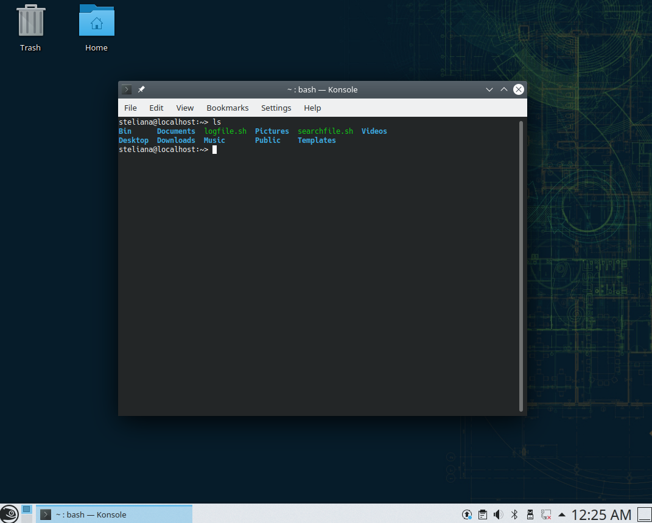

Then I checked if the file was deleted.